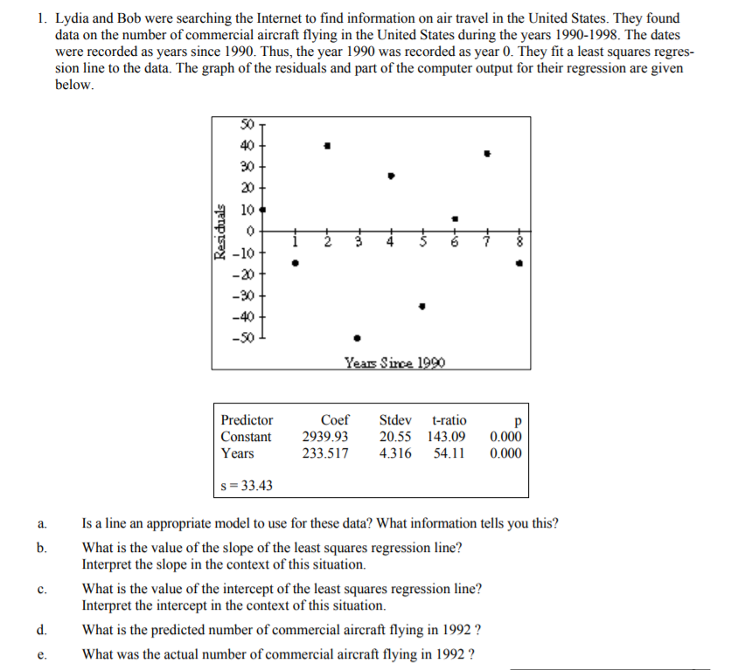

2. Suppose you own a local ice cream shop. You have taken 25 random days and observed the number of hours of “sun” and your ice cream sales. The relationship between these variables appears to be linear and you calculate a least squares regression line of  with  .

1. Interpret the slope of the regression line in the context of this question.
2. Interpret in the estimate of the intercept for the least squares regression line in context of this question.
3. Interpret the correlation coefficient in context of this situation.
4. Identify and interpret the coefficient of determination, 
5. Predict for a day that has 6 hours of sun.
6. If the residual for the day with 6 hours of sun was 10.50, what was the actual sales that day?

3. We are interested is seeing if the standardized math score that a students earns in 4th grade can help predict their standardized test score in 8th grade. In the article “Mixed Progress in Math” (*USA Today*, August 3, 2001), there was a list of data produced for 4th graders in 1996 and the same students as 8th graders in 2000. The summary results were as follows: The mean percent of 4th graders that were proficient in Math was 17.5 with a standard deviation of 4.401. The mean percent of 8th grade graders that were proficient in math was 23.5 with a standard deviation of 8.159. If the correlation coefficient was 0.82, find the LSRL of 8th grade math proficiency on 4th grade math proficiency.

4. If a residual plot created from a least squares regression of population on time shows a curved pattern, what can you say about the relationship between time and population?

